Analog to Digital Convertor

# Overview

This application note provides details on using the Analog to Digital Converter (ADC) peripheral of Talaria TWO modules.

# Analog to Digital Converter (ADC)

Talaria TWO modules have a 10-bit effective SAR ADC for measuring the internal supply voltage and temperature levels in addition to measuring an external voltage level through a specified ADC port.

|  |  |  |
| --- | --- | --- |
| **ADC Specification** | **Details** | **Unit** |
| ADC Input Channels | VBAT, TEMP, EXT | -- |
| External Voltage Input Range | 0 to 1.0 | V |
| Additional Delay for ADC Ready after Wakeup | 5 | μs |

Table 1: ADC Specifications

## ADC block diagram

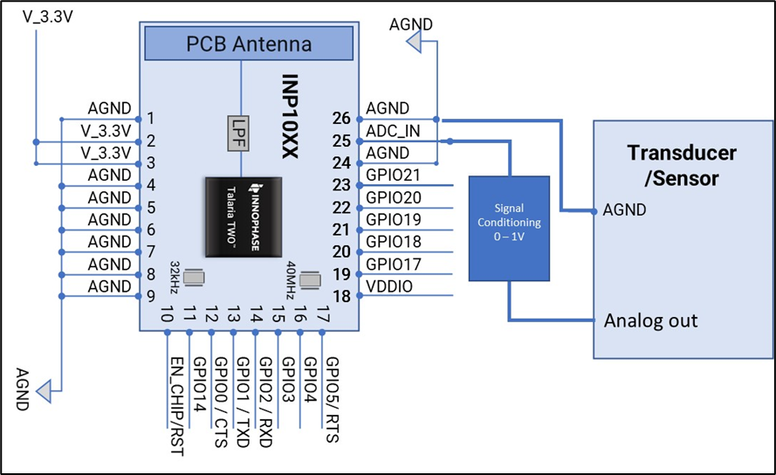

Figure 1: ADC - Block Diagram

# VBAT Voltage

VBat is the Voltage of the Battery. It could be used to power a component that takes Battery Voltage.

Header J4 will switch between VBat and Vm_3.3V.

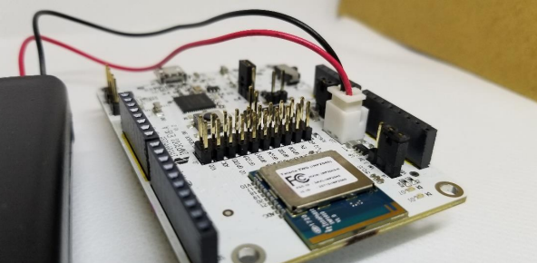

Figure 2: J10 Battery connection

When using a battery as a power source, there will be an additional current drawn from LED (D7 or D12 depending on board version). If attempting to measure an accurate module current drawn from the battery connection, the LED series resistor must be removed to disconnect the LED.

It configures the clocking and power profile of the block to match the current source and optimize energy consumption. When the device is powered through the VBAT Domain most of the circuits are powered down to conserve energy.

Based on the mode, The power for module is derived from either USB or shield header. A battery header is available which can be used as power source as well.

1. J4 at VM_3.3V for USB power
2. J4 at VBAT and battery connect to J10 for Battery power

## VBAT block diagram

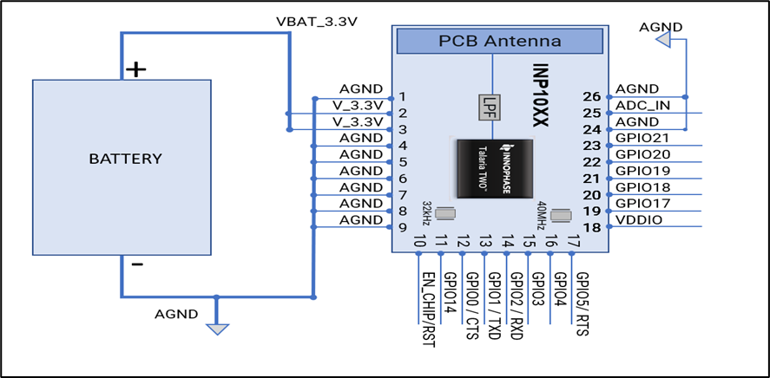

Figure 3: VBAT-Block Diagram

# Source Code Walkthrough

## Application flow

The application displays the raw value that varies according to the input provided to the ADC pin. Apart from the raw value measured out of the ADC pin, the internal temperature in integer Celsius and the VBAT in mv measured from source are also displayed.

This sample application:

1. Reads the internal temperature and prints the value
2. Reads the external ADC input and prints the value
3. Prints the internal temperature in integer Celsius

## ADC APIs

1. os_vbat()- Reads VBAT voltage

This API is used to enable the VBAT mode. A back-up source must be connected to VBAT pin. The voltage value (in millivolt) on the VBAT pin is returned.

1. os_adc()- Reads external ADC input

Displays the raw value to the input provided to the ADC pin.

1. os_core_temp() – Reads internal temperature

The inner temperature (in integer Celsius) of the chip core is displayed.

## Source file

### adc.c

Following is the example code which displays the ADC raw value for an external input voltage fed through the the ADC pin, VBAT and internal temperature of Talaria TWO.

1. os_adc()converts the analog input at the ADC pin and prints raw data as an output.
2. os_vbat()prints the VBAT voltage in millivolt from the back-up source on the VBAT pin
3. os_core_temp()reads the internal temperature and prints the temperature in internal Celsius type.

|  |
| --- |
| os_msleep(1000);  os_printf("ADC External value: %d\n",os_adc());  os_printf("V_BAT: %d mv\n",os_vbat());  os_printf("Internal Temperature: %d Celsius\n",os_core_temp()); |

# Building

To build the sample application, execute the following commands from SDK directory:

|  |
| --- |
| cd examples/adc  make |

The make command should generate the adc.elf in the out directory.

# Running the Application

## Programming Talaria TWO device using the Download Tool

Program adc.elf (sdk_x.y\examples\adc\bin) using the Download tool:

1. Launch the Download tool provided with InnoPhase Talaria TWO SDK.
2. In the GUI window:
   1. Boot Target: Select the appropriate EVK from the drop-down.
   2. ELF Input: Load the adc.elf by clicking on Select ELF File.
   3. Programming: Click on Prog Flash.

For more details on using the Download tool, refer to the document: UG_Download_Tool.pdf (path: *sdk_x.y/pc_tools/Download_Tool/doc*).

**Note**: x and y refer to the SDK release version. For example: sdk_2.4/doc.

## Expected Output

On flashing the application using the Download Tool, the console output is as follows:

|  |
| --- |
| UART:NWWWWAE  Build $Id: git-b664be2af $  hio.baudrate=115200  flash: Gordon ready!  UART:NWWWAEBuild $Id: git-b664be2af $  ADC Example  ADC External value:0  V_BAT:3253 mv  Internal Temperature:28 Celsius  ADC External value:82  V_BAT:3252 mv  Internal Temperature:28 Celsius  ADC External value:45  V_BAT:3252 mv  Internal Temperature:28 Celsius  ADC External value:73  V_BAT:3253 mv  Internal Temperature:28 Celsius  ADC External value:72  V_BAT:3252 mv  Internal Temperature:27 Celsius  ADC External value:44  V_BAT:3252 mv  Internal Temperature:28 Celsius  ADC External value:73  V_BAT:3253 mv  Internal Temperature:28 Celsius  ADC External value:72  V_BAT:3252 mv  Internal Temperature:28 Celsius  ADC External value:73  V_BAT:3252 mv  Internal Temperature:27 Celsius  ADC External value:45  V_BAT:3253 mv  Internal Temperature:28 Celsius  ADC External value:72  V_BAT:3253 mv  Internal Temperature:28 Celsius  ADC External value:80  V_BAT:3252 mv  Internal Temperature:28 Celsius  ADC External value:72  V_BAT:3253 mv  Internal Temperature:27 Celsius  ADC External value:73  V_BAT:3252 mv  Internal Temperature:28 Celsius  ADC External value:72  V_BAT:3253 mv  Internal Temperature:28 Celsius  ADC External value:45  V_BAT:3252 mv  Internal Temperature:28 Celsius  ADC External value:73  V_BAT:3253 mv  Internal Temperature:28 Celsius  ADC External value:72  V_BAT:3251 mv |